Thursday 24th July  Patchwork Chicken Panel Workshop | WI House  17 Couch Lane  Devizes SN10 1EB
A workshop where you will learn to make a patchwork chicken panel.  All materials provided along with the pattern for you to create more at home. A choice of colours are available. You will be cutting out the design on the day.  Please bring:  Working sewing machine with manual that you are familiar with, threads, scissors and a packed lunch.  Tea/coffee will be provided. | £30.00 per person to include all materials  10.00am – 3.30pm
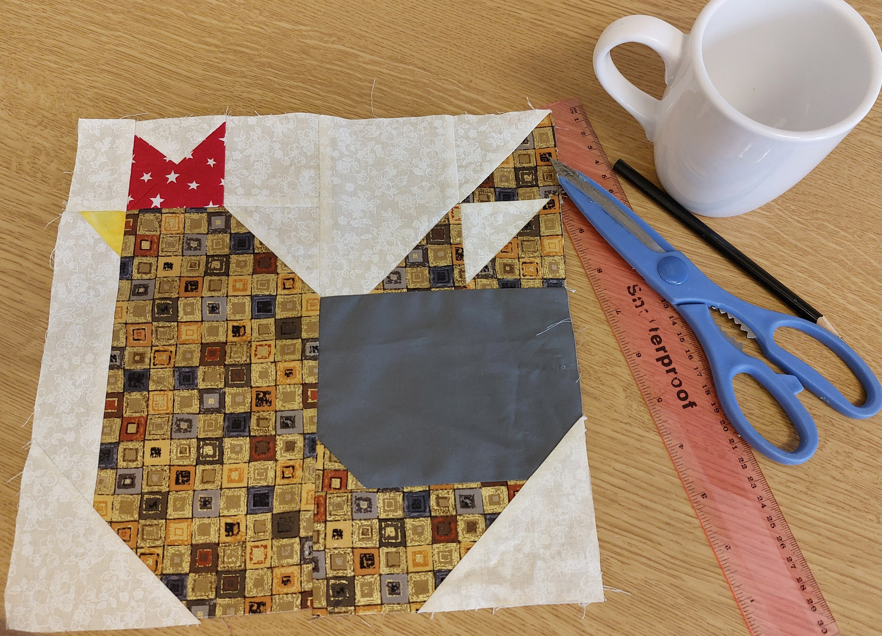
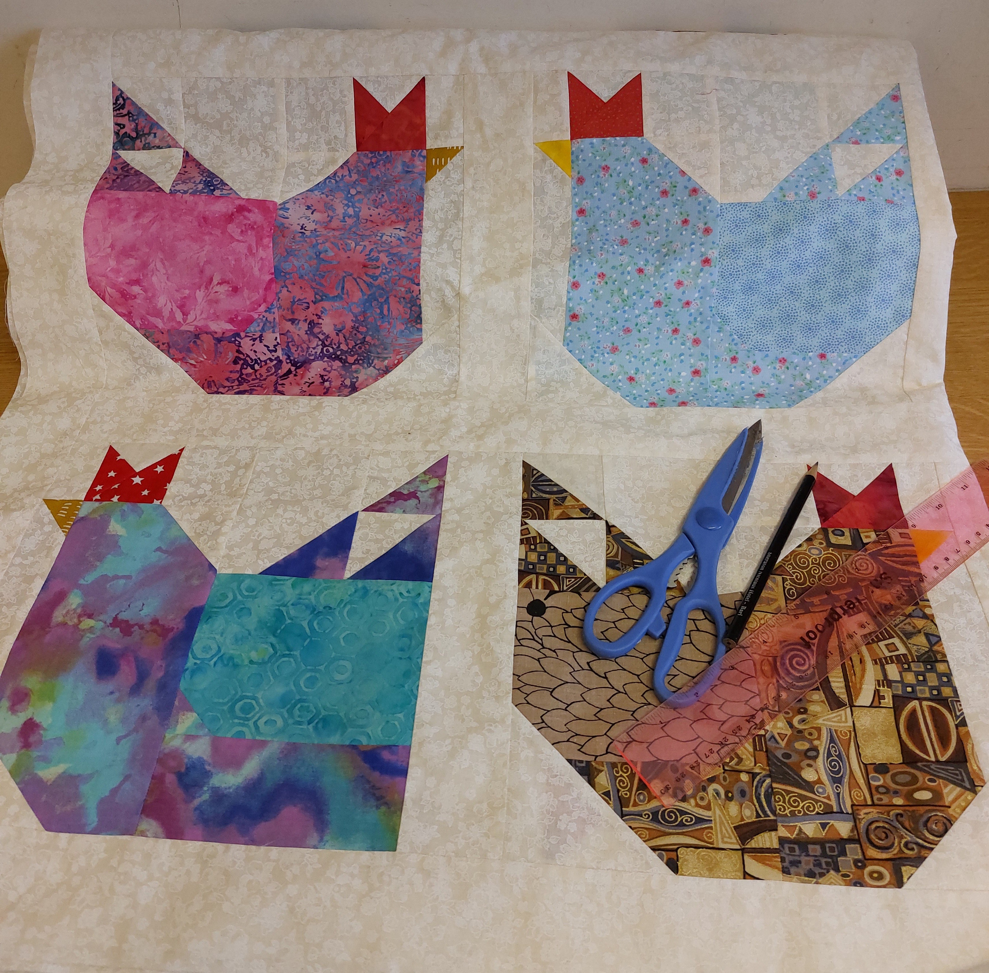

Enquiries to: WI House 01380 739340
Try Booking: https://www.trybooking.com/uk/EOFI
The following details must be emailed/ posted to: admin@wiltshirewi.org.uk  WI Name  Contact Name  Contact Email  Tickets Required  Total Payment Due  Attendees Names  Cheques to: WI House, 17 Couch Lane, Devizes SN10 1EB  BACs Payments: (use ref: WI Name & Chicken)  Account: Wiltshire Federation of WIs  Sort Code: 30 96 26 Account No: 79519268 |  | Closing Date: Thursday 10th July
Wiltshire Federation of WIs
WI House, 17 Couch Lane
Devizes SN10 1EB
Charity No: 1197142
 |  | 

