Eastbrook Farm Walk  Wednesday 14th May | Eastbrook Farm  Cues Lane, Bishopstone  SN6 8PL
Helen's family farm, Eastbrook & Lower Farm, spans 1500 acres across the Marlborough Downs and Vale of the White Horse. She is the CEO of the Soil Association and will be leading the walk, in person, to explain the history of the farm, giving an up close and personal look.
The walk is not suitable for those with limited mobility as you will be walking for an hour and a half, over varying terrain. Husbands / partners / non-members are welcome to join this event.
Join us at midday for lunch at the Royal Oak Pub (part of the farm) - order on the day and pay the pub directly. The walk will start at 1.30pm taking in the beautiful fruit orchards and wonderful views from the Ridgeway.

Robust footwear and warm / wet weather gear may be necessary!
£10.00 per person

12 noon for lunch
1.30– 3.00pm walk
 | 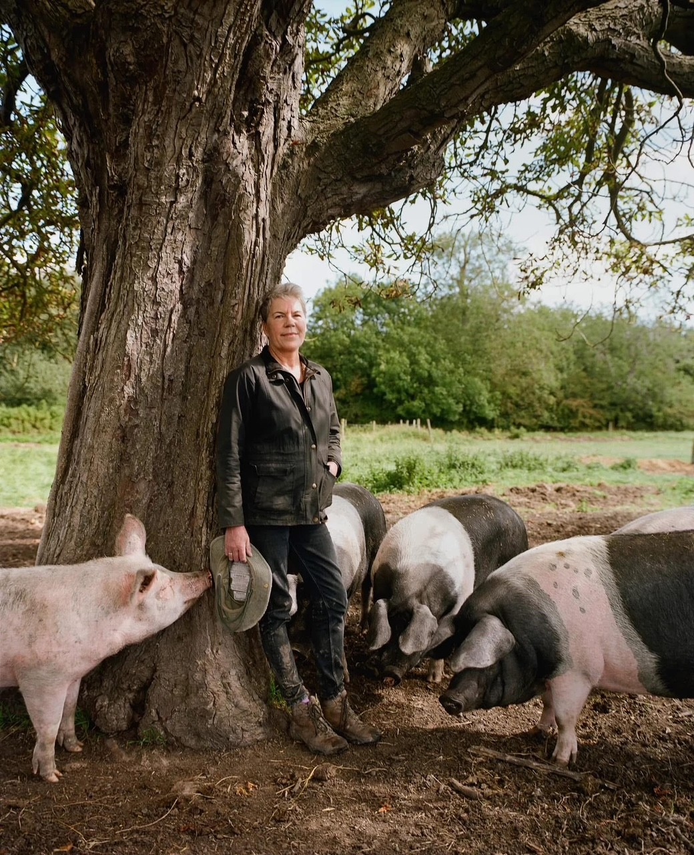
 | 
Enquiries to: WI House 01380 739340
Try Booking: https://www.trybooking.com/uk/EQCZ
The following details must be emailed/ posted to: admin@wiltshirewi.org.uk  WI Name  Contact Name & email address  Number of tickets Required  Attendee’s Names  Total amount due  Cheques to: WI House, 17 Couch Lane, Devizes SN10 1EB  BACs Payments: (use ref: WI Name & Eastbrook)  Account: Wiltshire Federation of WIs  Sort Code: 30 96 26 Account No: 79519268 |  | Closing Date: Thursday 1st May
Wiltshire Federation of WIs
WI House
17 Couch Lane
Devizes SN10 1EB
Charity No: 1197142
 |  | 

