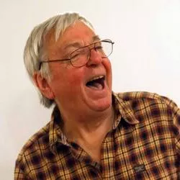 |  | ACTORS BEHAVING BADLY  with David Barry
Thursday 3rd April 2025
2.00pm – 3.00pm
Actor and writer David Barry has given many humorous talks about his years in theatre, film and television from when he began performing as a child actor aged twelve working with famous people such as Laurence Olivier, Vivien Leigh, Tyrone Power, Stephen Boyd, and has many funny anecdotes about some of the famous people he has worked with, including stories of when he played Frankie Abbott in the successful TV sitcom Please Sir! and Fenn Street Gang. Sometimes things in his career didn’t always run smoothly leading to some hilarious stories, especially when he met along the way comedians such as Tommy Cooper. The talk encompasses many interesting stories, especially when he toured to six European capitals playing in Shakespeare with Olivier and Vivien Leigh at the age of fourteen, the first British theatre company to perform in two communist bloc countries at the height of the Cold War. At this talk you will hear some fascinating stories.
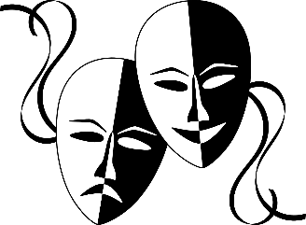 | The View @RWB Auctions  144 High Street  Royal Wootton Bassett SN4 7AB |  |  | 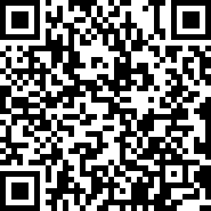
TICKET PRICE: £20.00 (includes tea/coffee)
Non-members welcome
CLOSING DATE: Wednesday 5th March 2025 (Unless fully booked)
ENQUIRIES TO: | WI House |  | Tel: 01380 739340
 |  |  | Email: fedsec@wiltshirewi.org.uk
Cheques will be banked once minimum numbers are reached. If a refund is due for any reason it will be sent accordingly.

