Sunday 8th June  Lacock Treasure Trail |  | National Trust  Car Park  Lacock SN15 2RQ
Lacock is a village and civil parish about 3 miles south of Chippenham. The village is owned almost in its entirety by the National Trust and was mentioned in the Domesday Book.  A chance to explore this historic village following clues you will be given on the day.  Teams can be up to 5 people with at least one being a WI member.  Meet in the car park by 2.00pm and return before 3.30pm. There will be a prize for the winning team but no extra points for being the quickest!  The National Trust car park is free for members or £5.00 per day.  Enquiries to: WI House 01380 739340 |  | £7.50 per team  2.00pm – 3.30pm
 |  | 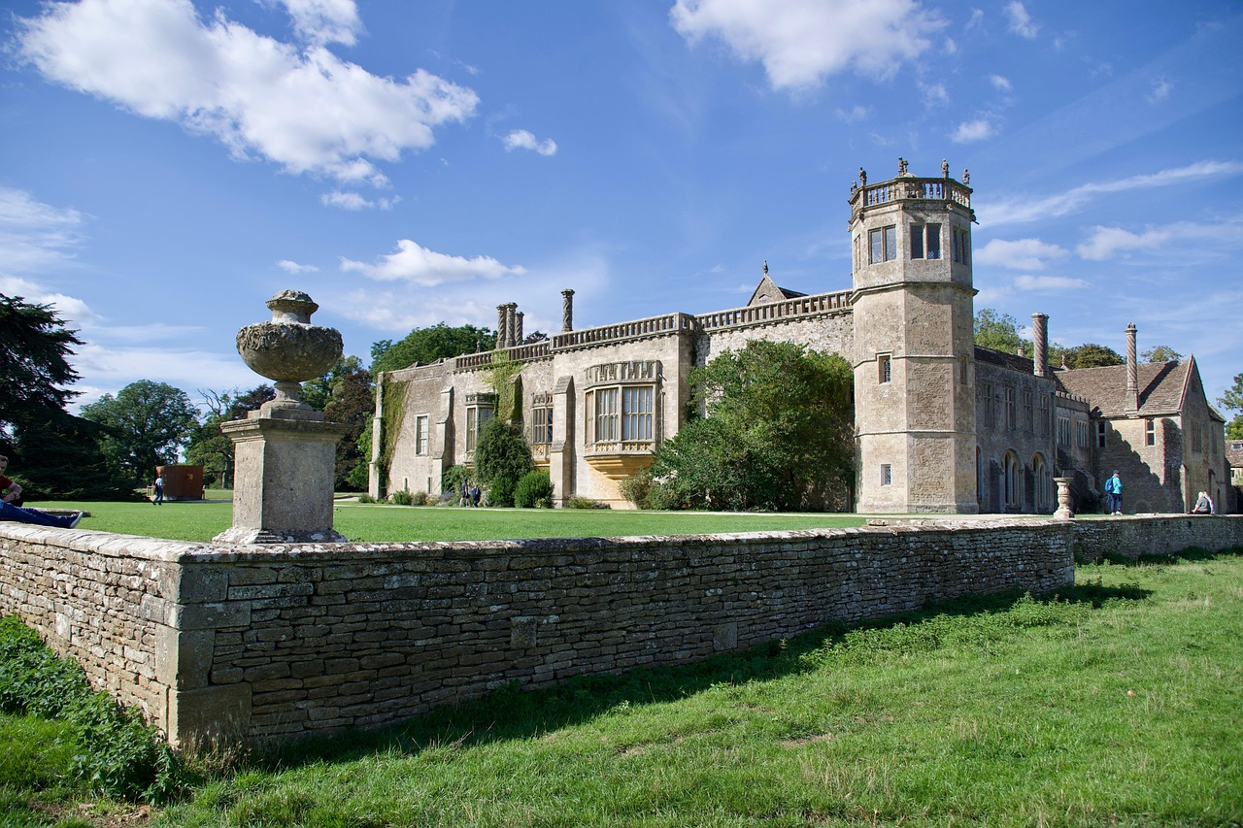
 |  | 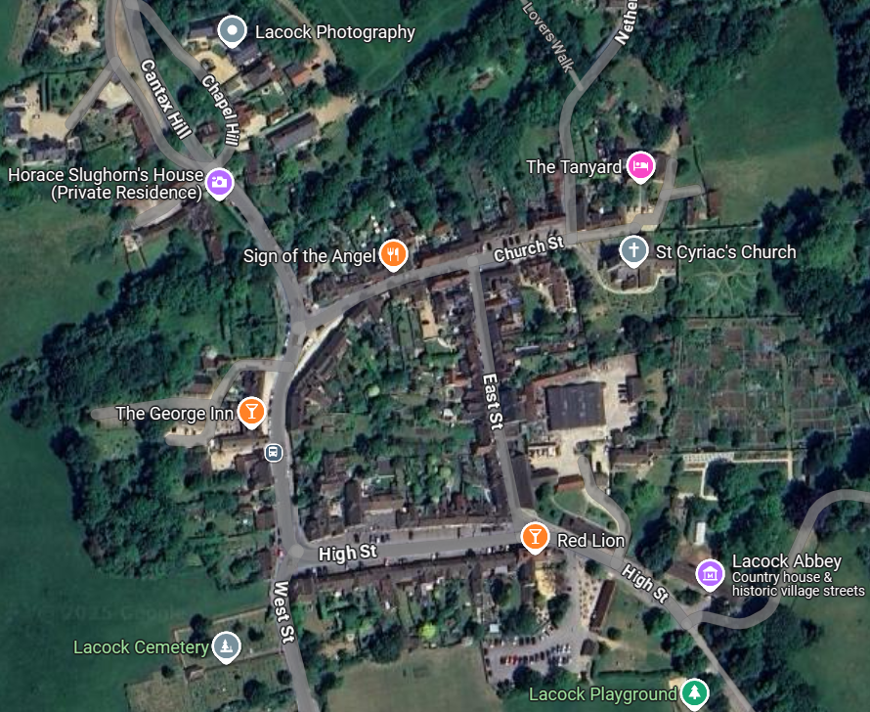
Closing Date:
Thursday 29th May
The following details must be emailed/ posted to: admin@wiltshirewi.org.uk  WI Name:  Contact Name:  Contact Email:  Tickets Required:  Total Payment Due:  Attendees Names: | 
 | Wiltshire Federation of WIs  WI House, 17 Couch Lane  Devizes SN10 1EB  Charity No: 1197142 |  | 
BACs Payments: (use ref: WI Name & TT2025)
Account: Wiltshire Federation of WIs Sort Code: 30 96 26 Account No: 79519268
Cheques to: WI House, 17 Couch Lane, Devizes SN10 1EB

