Filming Wildlife to Saving Lives: Fergus Beeley |  |  |  | 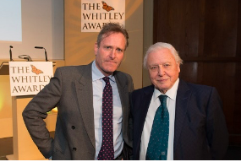
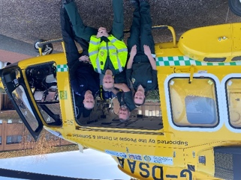 |  | Friday 28th February 2025  2.00pm – 4.00pm  (doors open 1pm) |  | 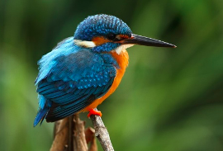
Fergus Beeley produced many BBC Natural Worlds programmes such as ‘Highland Heaven’, ‘The Monkey-Eating Eagle of the Orinoco’ and ‘White Falcon, White Wolf’. He also Produced BBC Planet Earth – ‘The future and Life of Birds’ with David Attenborough, as well as many other award-winning documentaries including Stoats in the Priory (1994) which is still the most repeated BBC film in their archive.
Fergus retired from the media and retrained as a combat medic technician and volunteered on the battle frontline in Ukraine in 2022. He subsequently founded and is CEO for Medevac Frontline, a charity sending teams of highly trained volunteer UK Paramedics to humanitarian disasters overseas. |  |  |  |  |  | 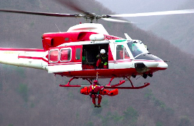
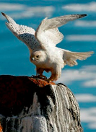 | Langley Burrell Village Hall  Manor Farm Lane  Chippenham SN15 4LL |  |  |  | 
Non-members are also welcome
TICKET PRICE: £20.00
tea, coffee and cake included in price
CLOSING DATE: Thursday 30th January 2025 (Unless fully booked)
ENQUIRIES TO: | WI House |  | Tel: 01380 739340
 |  |  | Email: fedsec@wiltshirewi.org.uk
Cheques will be banked once minimum numbers are reached. If a refund is due for any reason it will be sent accordingly.

