 |  | SEW A SUMMER HAT
Tuesday 22nd April 2025
10.00am – 3.30pm
Spend a crafty day at WI House learning to create a summer hat.  All materials provided. A small selection of colours will be available. Please ask beforehand if you would like a specific colour. Up to two styles to choose from.  Please bring a working sewing machine and threads/bobbins. Also, a packed lunch. Tea and coffee provided. |  |  |  |  | 
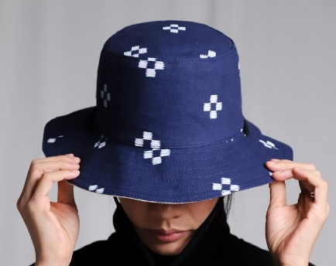 | WI House  17 Couch Lane  Devizes SN10 1EB |  |  | 
TICKET PRICE: £25.00
Non-members welcome
CLOSING DATE: Monday 14th April (Unless fully booked)
ENQUIRIES TO: | WI House |  | Tel: 01380 739340
 |  |  | Email: fedsec@wiltshirewi.org.uk
Cheques will be banked once minimum numbers are reached. If a refund is due for any reason it will be sent accordingly.

