 |  | NEW SPEAKERS’DAY  Wednesday 26th March 2025

West Lavington Village Hall

Sandfield, West Lavington SN10 4HL
10.45am until 3.30pm (Doors open at 10.15am)

This is an opportunity to attend and vote on behalf of all Wiltshire WIs for applicants to become authorised WI speakers for Wiltshire. It is permissible for WIs to pay for the Programme Secretary to attend. There is no restriction on the amount of additional tickets WI members can purchase.
TICKET PRICE: £10.00
Tea or coffee will be provided on arrival, and available to purchase
at lunch time. Cake will also be available to purchase at lunch time.
Lunch: Quiche, Potato Salad & Side Salad
Orders for lunch MUST be paid for in advance at £8.00 per person. You may still bring your own packed lunch.
Closing Date: Monday 17th March 2025  (Unless fully booked) |  |  |  | 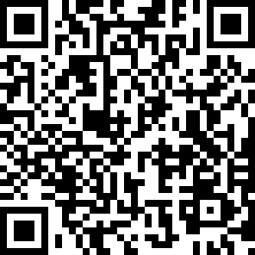
ENQUIRIES TO: | WI House |  | Tel: 01380 739340
(no ticket sales) |  |  | Email: fedsec@wiltshirewi.org.uk
Confirmation of booking will be emailed after closing date. No tickets will be issued. If a refund is due for any reason it will be sent accordingly.

