KEW GARDENS ORCHID FESTIVAL
 |  | Tuesday 18th February 2025  Coach Trip
From beaches and rainforests to deserts and mountains, Peru offers a varied landscape which is home to over 3000 species of orchid, and an incredible array of wildlife. This beauty and biodiversity will inspire a series of stunning horticultural displays and living sculptures in the Princess of Wales Conservatory at Kew Gardens in London.  With time to visit other attractions in the gardens including the Glass House and Pagoda.  There are a variety of cafes and restaurants offering hot and cold food to buy and, of course, gift shops. |  |  |  | 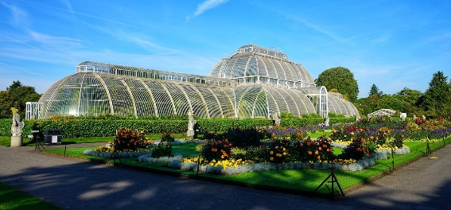  
Coach pick-up points:  CHIPPENHAM (Morrisons Supermarket) 7.45am  WROUGHTON (Ellendune Centre) 8.15am  DEVIZES (Station Road Car Park) 8.50am  AMESBURY (Countess Services) 9.30am |  |  |  | 
TICKET PRICE: £45.00
Non-members are also welcome.
CLOSING DATE: Tuesday 21st January 2025 (Unless fully booked)
ENQUIRIES TO: | WI House |  | Tel: 01380 739340
 |  |  | Email: fedsec@wiltshirewi.org.uk
Cheques will be banked once minimum numbers are reached. If a refund is due for any reason it will be sent accordingly.

